1779.   Tri Tiling

Time Limit: 1.0 Seconds   Memory Limit: 65536K  
Total Runs: 1213   Accepted Runs: 656

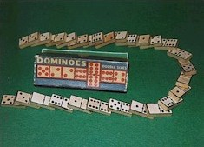In how many ways can you tile a 3x*n* rectangle with 2x1 dominoes?

Here is a sample tiling of a 3x12 rectangle.

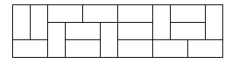

Input consists of several test cases followed by a line containing *-1*. Each test case is a line containing an integer *0 ≤ n ≤ 30*. For each test case, output one integer number giving the number of possible tilings.

**Sample input**

2

8

12

-1

**Output for Sample Input**

3

153

2131